Final Report

On

**Books4U**



**Submitted to**

**Department of Computer Science and Engineering**

Nepal Engineering College

**Submitted By**

Deepsana Thapa (017-327)

Prajwal Chaudhary (017-356)

Shekhar Chaudhary (017-380)

**Submitted Date: -** 22nd December 2019

**ABSTRACT**

Almost in each and every field usage of internet is taking place in some form. In the field of commerce and business, internet is being used for online listing of their product and carrying transactions for the buying or selling for the product or services. It is named as e-commerce. Also increase in online shopping in the field of e-commerce has forced nearly every field to go online for better profit.

The purpose of this project is to provide a platform to sell the used or new books. This web app is an excellent way to reuse the books. The system will offer a web-based interface for user to conveniently find buyers for their used books. Users willing to buy used books will be able to search the listing for the desired book and order it from any seller that is offering the book.

**Keywords: [**E-commerce, Books, Django, PostgreSQL]

**ACKNOWLEDGEMENT**

We would like to express our gratitude and appreciation to all those who gave us the possibility to complete this project. First of all, we would like to express a deeply thank to our supervisor Asst.Prof. Ishwor Pokhrel, teachers and faculty members of Computer Department, Nepal Engineering College for their demonstration of guidance, giving useful advice to conceptualize the project which enabled me to have clear understanding of our project. I also wish to extend my sincere and heartfelt gratitude to my classmates and friends who helped in various ways for successful completion of this project proposal. We are thankful to our parents, our source of inspiration, for their continuous love, encouragement and support. Finally, we would like to appreciate all those who have contributed their innovative ideas and also their valuable time without which it would have been a difficult task for us to frame a project in a time bound framework.

**Table of Contents**

**Chapter 1: INTRODUCTION** 1

**1.1 Problem Statement** 1

**1.2 Objective** 1

**1.3 Scope** 1

**Chapter 2: Literature Review** 2

**2.1 Amazon.com** 2

**2.2 eBay** 2

**2.3 Hamrobazar.com** 2

**Chapter 3: System Design** 3

**3.1MODULES** 3

**3.1.1 Admin** 3

**3.1.2 User** 3

**3.2 System Requirements** 6

**3.2.1 Software Requirements** 6

**3.2.2 Hardware Components** 6

**Chapter 4: Implementation and Discussion** 7

**4.1 Task Completed** 7

**4.2 Output Obtained** 7

**Chapter 5. Analysis and Evaluation** 8

**Chapter 6: Conclusion** 9

**References** 10

**Appendix** 11

# **Chapter 1: INTRODUCTION**

Internet is the global system of interconnected computer networks that use the internet protocol suite to link devices worldwide. It has been used for various purposes to make human life easier. E-commerce, web forum, social networking sites are few of them.

E-commerce is the activity of buying or selling of products on online services or over the internet. Electronic commerce draws on technologies such as mobile commerce, electronic funds transfer, supply chain management, internet marketing, online transaction processing, electronic data interchange, inventory management systems, and automated data collection systems.

## **1.1 Problem Statement**

Nowadays because of people’s busy lifestyle they usually have no time to go and buy books in physical stores. And with the increase in prices of every possible things buying them have become hard enough. So, they are in search of a platform to buy books in reasonable prices without sacrificing the quality. Hence, an online book reseller would be great choice for such. Also, being able to sell the books they don’t want to keep with them is a welcome feature.

## **1.2 Objective**

* To provide an essence of online book store
* To provide simple & yet powerful medium
* To simulate the working of an actual online book store
* To provides user with easy user- interface to buy and sell books

## **1.3 Scope**

This web app can be easily implemented under various situations. Various updates can be performed in this web app in coming future. The project made here is just to ensure that this product could be valid in today’s real challenging world. Here all the facilities are made & tested. It will provide platform to connect buyers and sellers easily. This web app will result in minimizing the gap amongst different users. This platform results in an easy way of communication amongst different people from different areas.

# **Chapter 2: Literature Review**

During research of this project, several articles, E-commerce websites have been reviewed. Most of which are taken from the internet.

## **2.1 Amazon.com**

Used books can also be sold through the Amazon.com Marketplace. However, Amazon.com charges the seller $0.99 plus a 15% commission fee for each book sold. In addition, the seller has to deal with the shipping of the books to any part of the country. Amazon.com credits some of the shipping charges to the seller, but the seller will often have to spend more money on shipping depending on the size and weight of the package. The general model that Amazon.com provides is what we might call the “retail model”— the sellers are forced to compete among themselves to offer the lowest price for a particular book. This model is convenient for buyers because they do not have to deal with bidding and waiting for the auctions to finish [1].

## **2.2 eBay**

Another popular place for selling and buying books online is eBay. They use the “auction model”— the seller sets up an auction for a certain duration and the buyer with the highest bid at the end of the auction buys the book. There are several drawbacks to this model. Usually, students start looking to buy books online right at the beginning of the semester, when they need to get them fast. They cannot afford to wait until the end of the auction to just find out whether they won the bid. In addition, eBay charges the seller an insertion fee which ranges from $0.25 to $4.80, and an auction closing fee which is about 5.25% of the final value. The insertion fee is charged even if the item is not sold at the end of the auction [2].

## **2.3 Hamrobazar.com**

Moving to Nepalese market, we have got “**hamrobazar.com”** as a viable option for selling used products. The seller has to post their products as the ads as per the terms and conditions. Hidden commissions are not charged to the seller or the users. The main drawback of this platform seems to be the unmanaged delivery system. The seller and buyer have to meet at the specific place in order to final the deal. And, also the UI seem to be too zigzag & clumpsy.

# **Chapter 3: System Design**

## **3.1MODULES**

### **3.1.1 Admin**

* **Login:** Using valid login credentials, admin need to login into the system in order to access the system.
* **View Books:** Admin can view all the added books online with their details.
* **View Transaction:** System allows admin to view all the transaction details of buying and selling a book.
* **View User:** All the registered user details will be displayed to the admin.

### **3.1.2 User**

* **Registration:** User need to register first with their basic registration details and need to create a valid login id and password.
* **Login:** Using valid login credentials, user need to login into the system in order to access the system.
* **View Books:** Once user is logged in, he/she may view all the added books with their details.
* **Buy Books:** User can surf various book of their choice and buy them.
* **Add Books:** System allows user to sell their books online by adding the book name and its details.
* **My Orders:** All the purchase history of user will be displayed with details.
* **View Buyer:** If any buyer is interested in buying a book or anyone buys a book from the user then buyer’s details will be displayed.

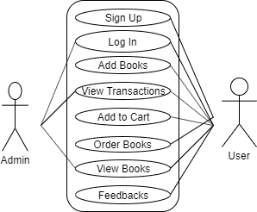

Fig 3.1: Use Case Diagram for ‘**Books4U**’

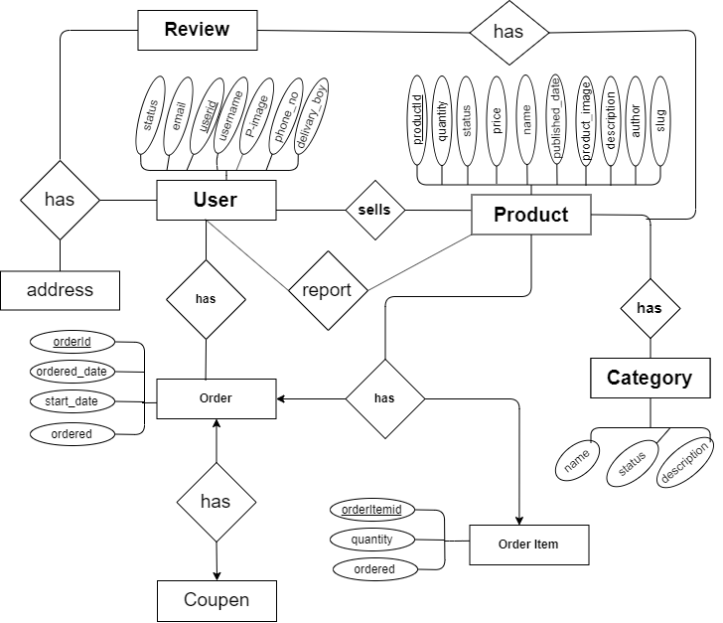

Fig 3.2: - ER Diagram of ‘**Books4U’**

## **3.2 System Requirements**

### **3.2.1 Software Requirements**

* Windows 10, macOS & Linux
* Python
* Django Framework
* PostgreSQL

### **3.2.2 Hardware Components**

* Processor – Intel atom processor or Core i3 processor
* Disk Space – 50 GB
* RAM – 2GB

# **Chapter 4: Implementation and Discussion**

## **4.1 Task Completed**

Following task are completed for the project:

* The login page is created where the user can sign in to the app.
* Homepage and product page are created
* Users will be able to add the books for sale.
* Users will be able to add product in their cart.

## **4.2 Output Obtained**

Following output is obtained as the result for the above completed tasks:

* The login page is seen at the start where users can sign in and has an easy user interface.
* Easy interface is seen where teacher can add books for sale.
* Product can be added or removed from the cart.
* User can give review & report product
* User can use coupon

# **Chapter 5. Analysis and Evaluation**

Before developing the system, it is crucial for requirement collection and analysis. This phase was used to determine the requirements such as: who are target group for system? How will they use the system? How will they be benefited by using this system? These were the type of question that were answered during the requirement gathering. After requirement gathering was completed, requirements were analyzed to determine whether or not these requirements can be measured and tested. Once, requirements analysis was completed, the designing of the system was initiated.

After the complete of our project, we were able to create an authentication system and registration system and user can easily register and login to the system. Both registered and unregistered users were able to search books. Admin has full control over full system.

# **Chapter 6: Conclusion**

In conclusion, the project mainly focuses on the buyer who are willing to buy second hand books rather than fresh ones. Similarly, for the users who have old books will have the choice to sell them. This platform also promises to provide best deals to the users since they have more choices to opt from.

# **References**

[1] J.B. Schafer, J.A. Konstan, and J. Reidl, "E-Commerce Recommendation Applications," Data Mining and Knowledge Discovery, Kluwer Academic, 2001, pp. 115-153.

[2] P. Resnick, et al., "GroupLens: An Open Architecture for Collaborative Filtering of Netnews," Proc. ACM 1994 Conf. Computer Supported Cooperative Work, ACM Press, 1994, pp. 175-186.

# **Appendix**

Review Page

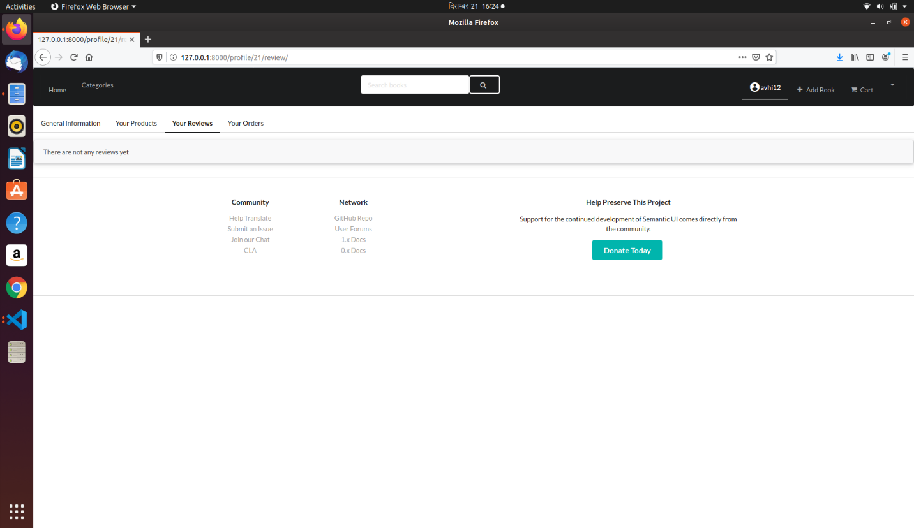

Product Add Page

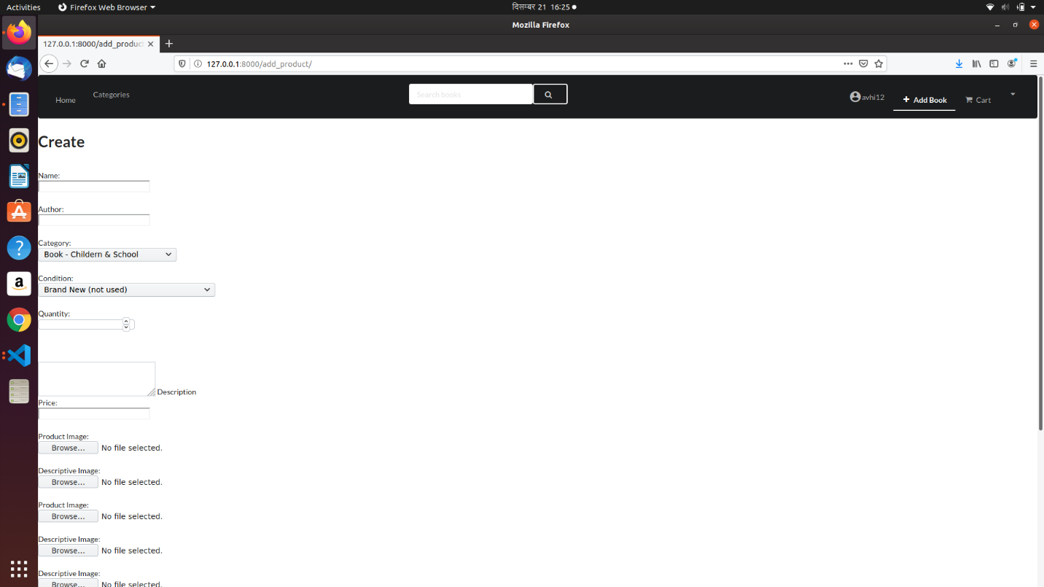

Cart Page

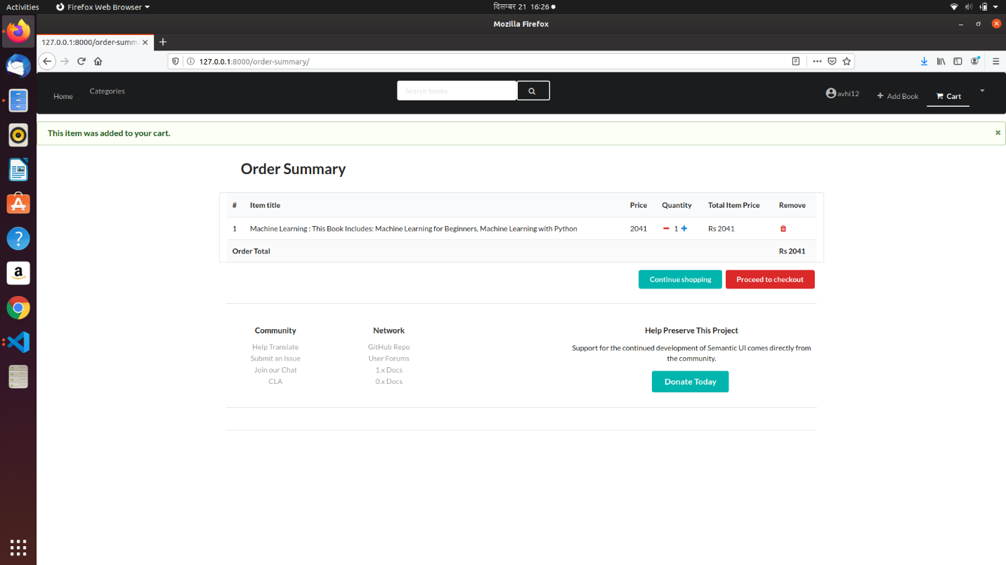

Category Page

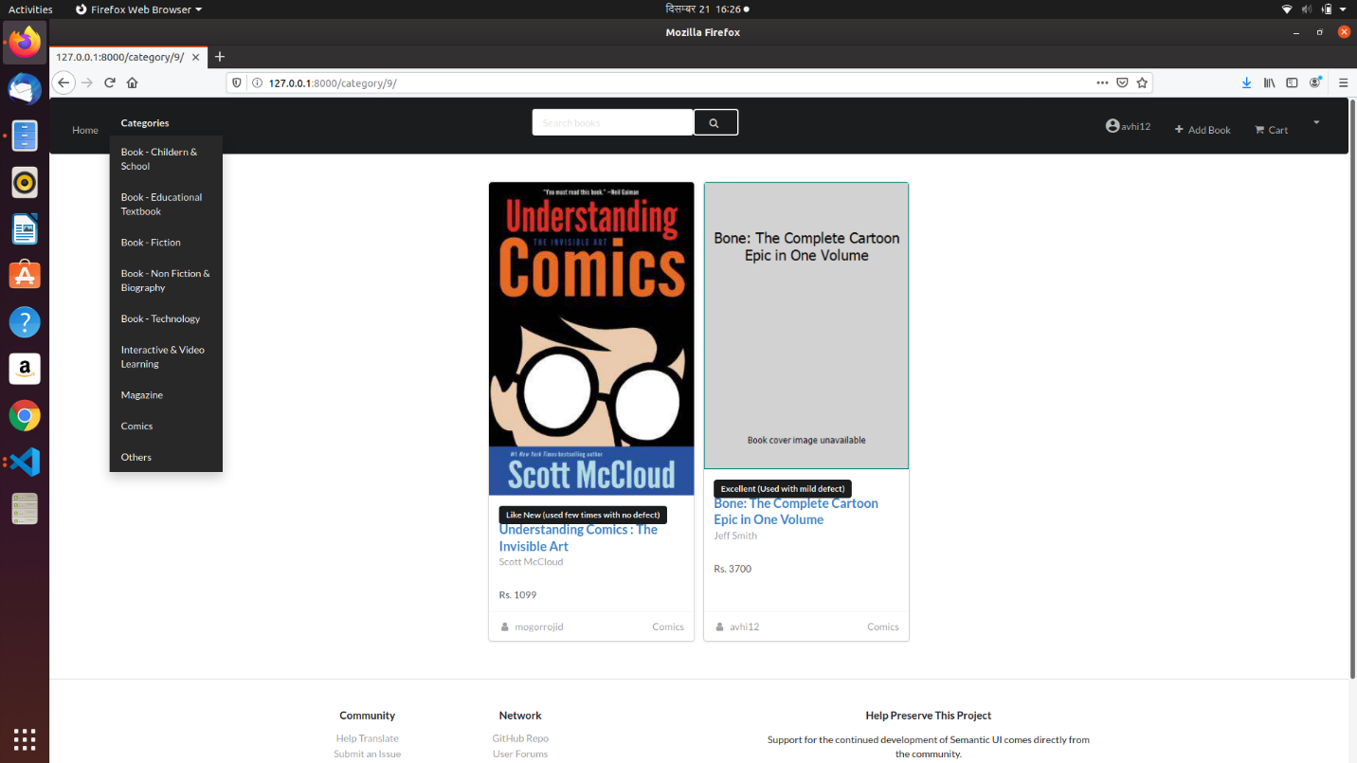

For you page

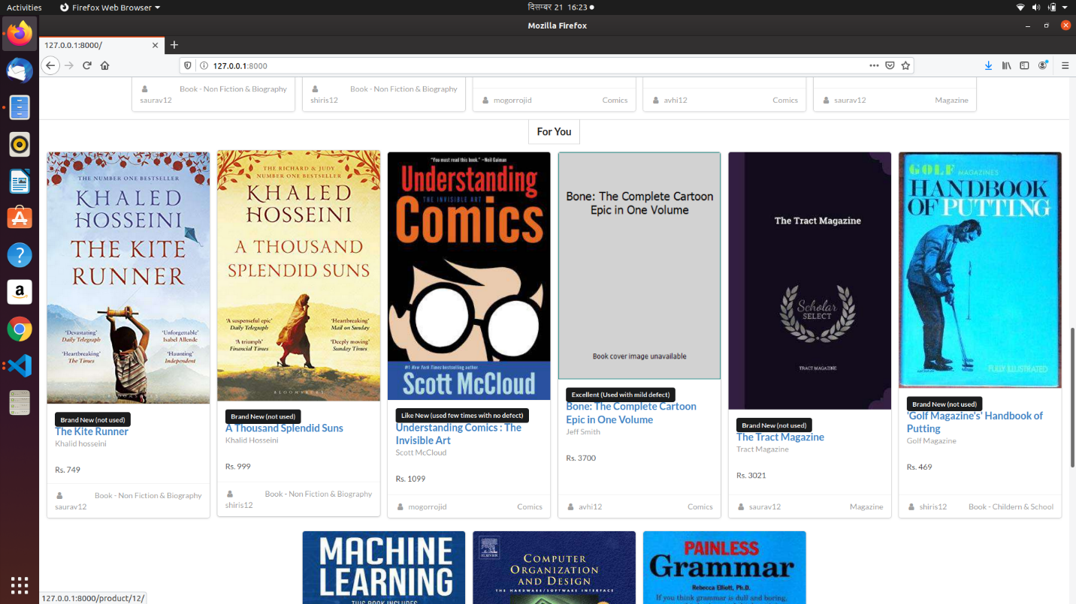

Homepage

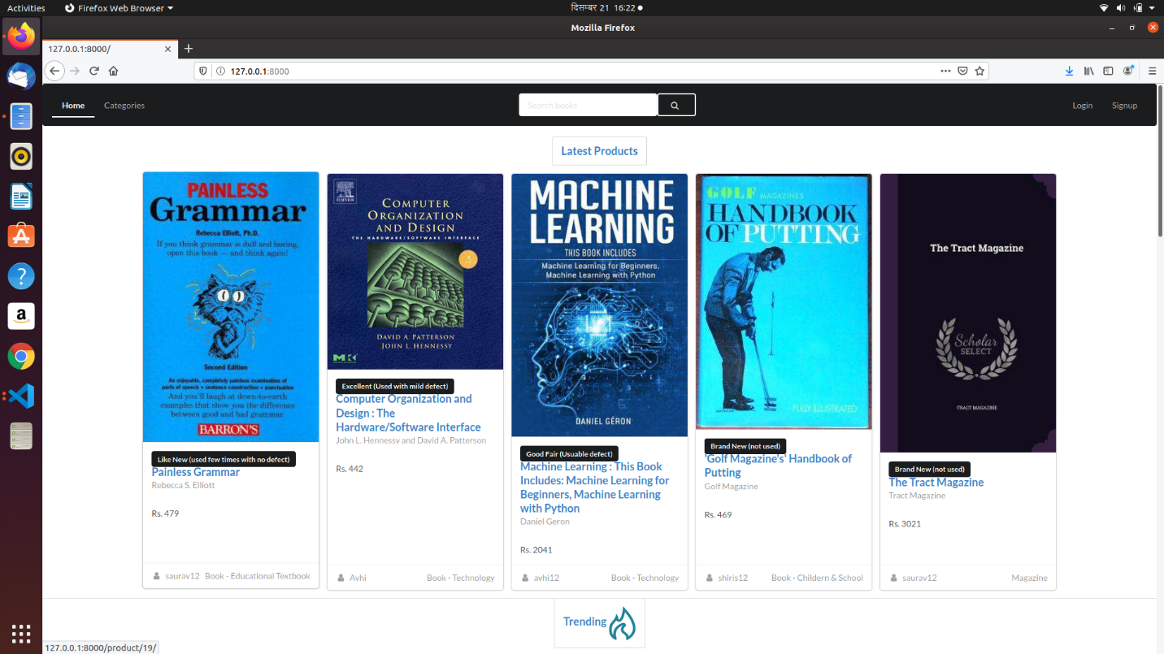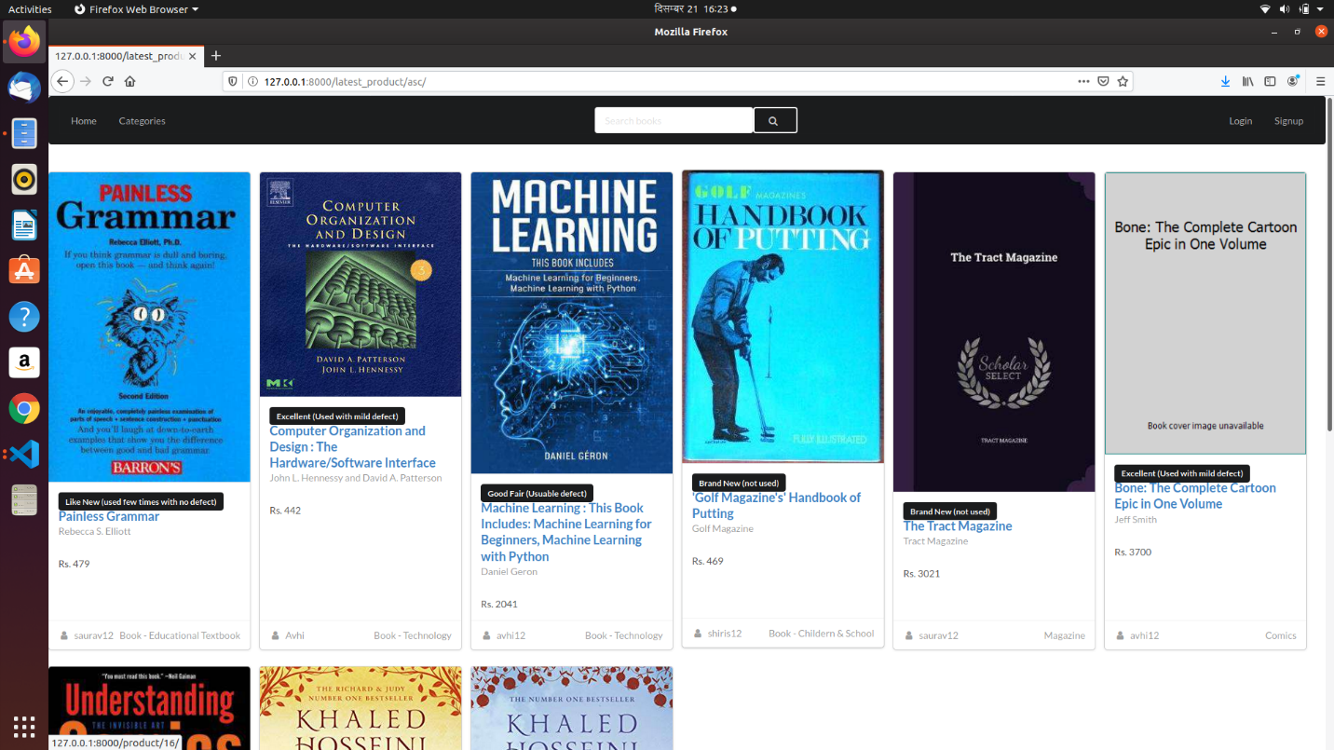

Profile Page

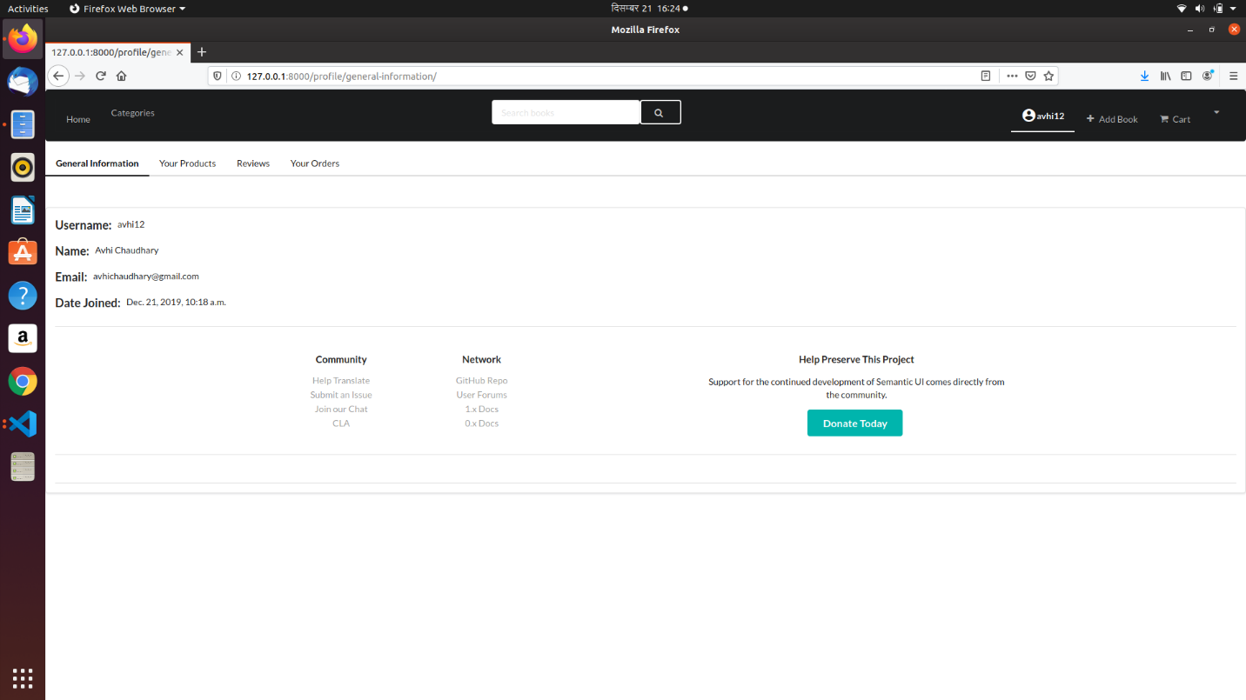

Search page

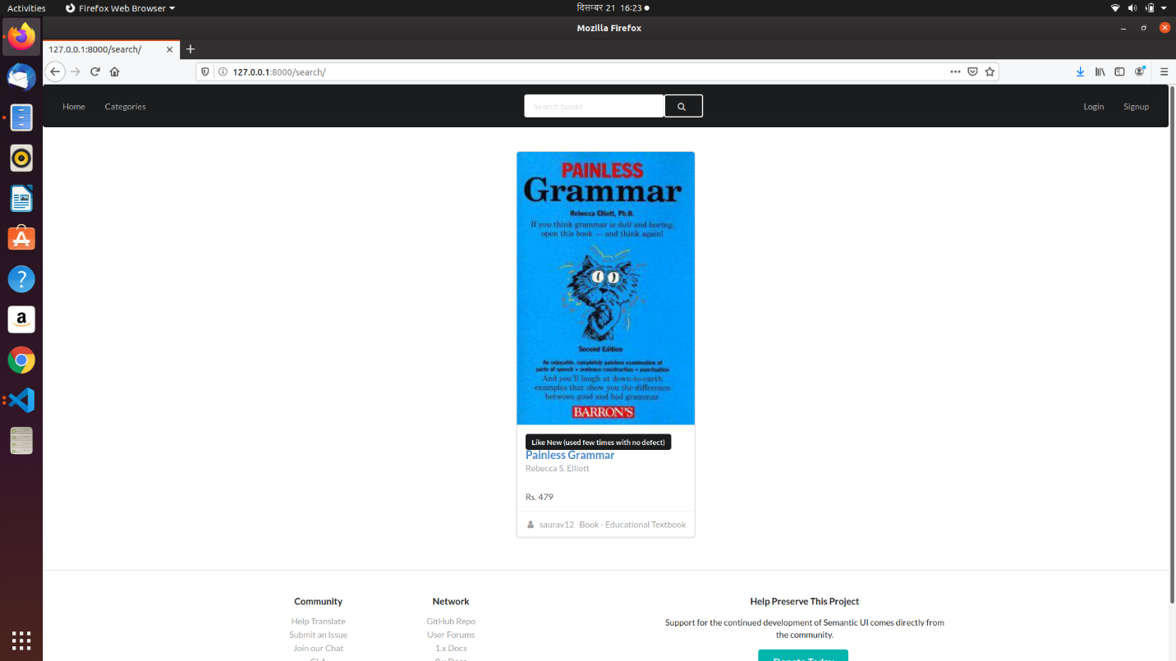

Sign In Page

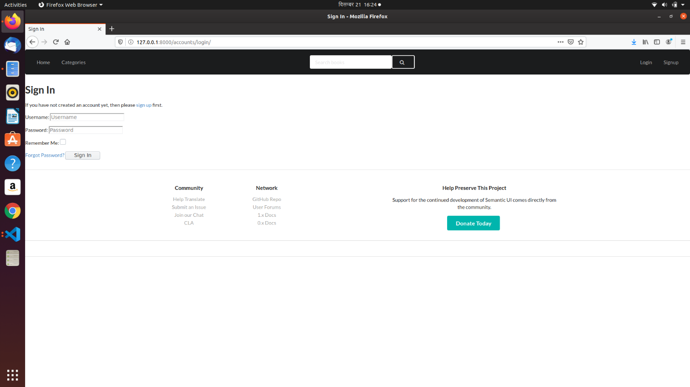

Signup page

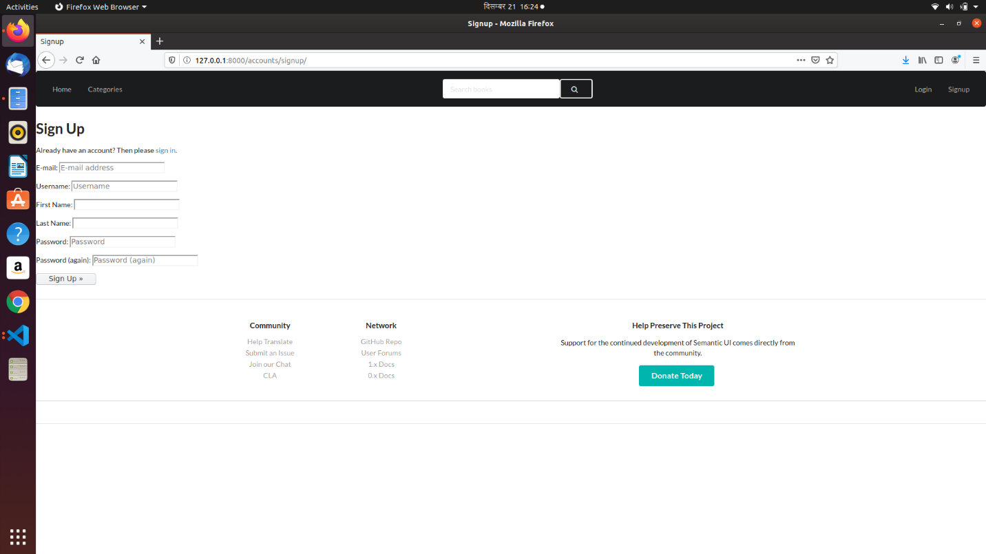

Trending Page

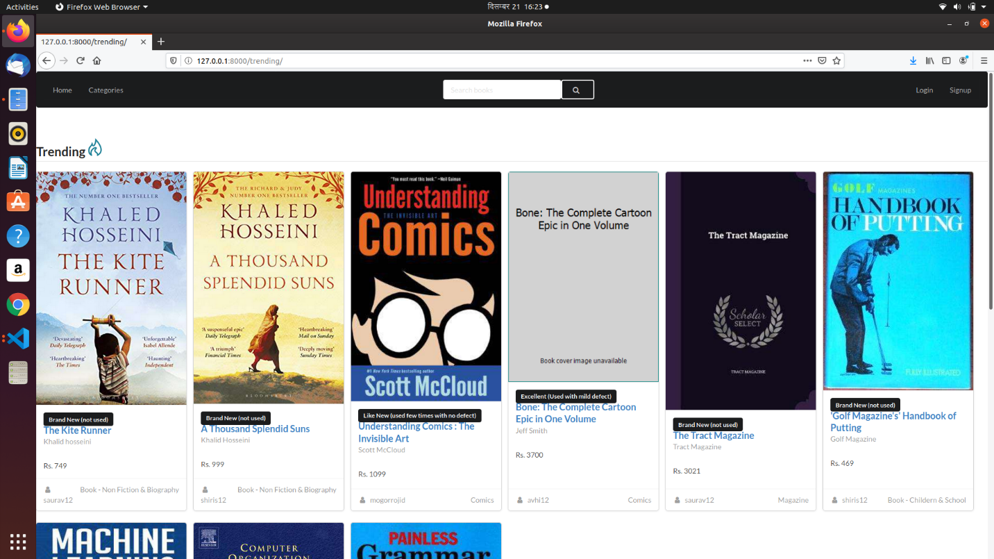

Order Page

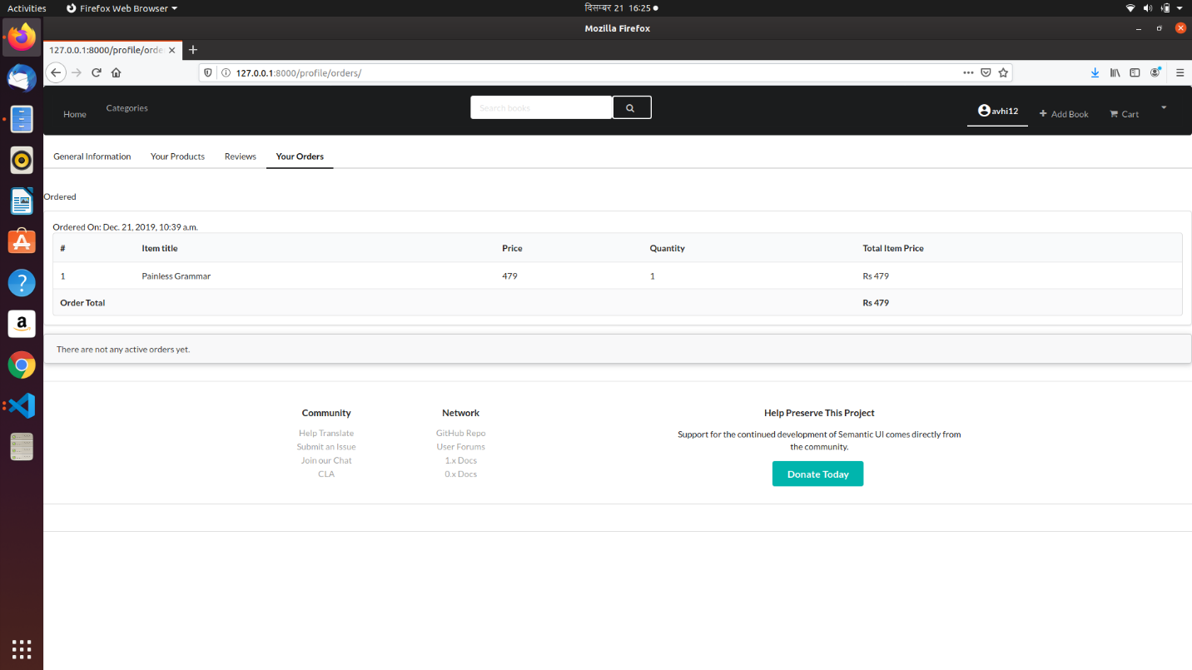

Product Page

